Procurement System

Technical Design Specifications

: Version 0.1

Project Code | :
Reference ID | :

Revision History

Version | Effective Date | Summary of Change | Prepared by | Approved by
0.1 | 02/07/2011 | Draft version | Cheng Zhang
TABLE OF CONTENTS

1 Introduction 4
1.1 Purpose 4
1.2 Scope 4
1.3 Definitions, Acronyms and Abbreviations 4
1.4 References 4
2 System design overview 5
2.1 Overall Architecture 5
2.2 Presentation Tier 6
2.3 Business Tier 6
2.4 Data Access Tier 6
3 page flow illustration 6
3.1 Rending Data via XHTML 6
3.2 Incoming request 8
3.3 Interacting with business logic service 9
3.4 Interacting with backend database via Data Access Objects 10
3.5 Displaying the result 11
4 System / component integration sequence 11
5 DATABASE/FILE DESIGN 12

Introduction

Purpose
This document describes the design of the Procurement System created for NCS Procurement Team to maintain product and order information with Optus.

Scope
In scope of this document are the architecture changes specific to the procurement system in terms of how it is to be coded. The system was build on top of latest NCS i.Frame. To understand procurement system, a good understanding of i.Frame is pre-requisite.
This document will introduce i.Frame in high level, and then explain every part in detail how procurement system was implemented and configured.
The scope of this document will cover following sections:
- i.Frame Overview – covers high level concept of i.Frame
- i.Frame Web Application Framework – provide a detailed description of the various tiers of the web application framework
- Page flow Illustrations – provide walkthrough of how a request is handled by Procurement System using i.Frame.

Definitions, Acronyms and Abbreviations
Term, Acronyms and Abbreviations | Definition
JSF | Java Server Face
MVC | Model-View-Controller

References
No. | Author | Title | Reference | Version no. | Date | Pages

System design overview

Overall Architecture
Procurement System is designed on top of i.Frame framework. I.Frame 4 is a new generation framework. It will base on below existing framework:
- JSF 2.1
- Primefaces 2.2.1
- Spring 3.0.3
- Hibernate 3.3.2.GA
- Spring DM 1.2.1
The system adopts JSF 2.1as the default web tier framework, which is a server-side Java implementation of the Model-View-Controller (MVC) architecture. Java Server Faces is a standard Java framework for building user interfaces for Web applications. Most important, it simplifies the development of the user interface, which is often one of the more difficult and tedious parts of Web application development.
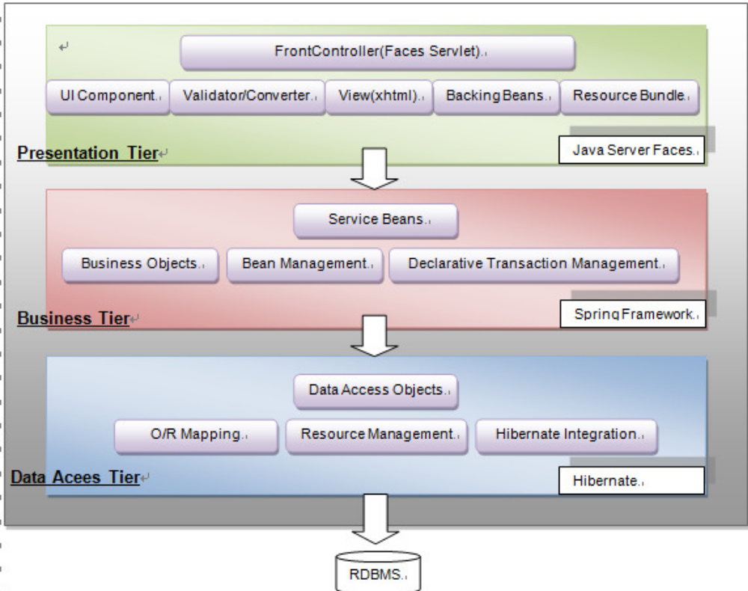

Presentation Tier
The major components of the presentation tier for Procurement System are:
- The Faces Servlet Contoller is able to intercept all faces request.
- The backing beans are the Java Objects that store application data and do not implement or extend any framework specific interfaces or classes are commonly referred to as Plain Old Java Objects (POJOs). This wills resilience to changes in the kind of view technology used. Better maintainability and testability.
- In general, a UI component is a self-contained piece of software with a well defined usage contract that is used by another piece of software. A user interface component (UI component) is a specific type of component that displays user interface content which the user can modify over time. This content ranges from simple input fields or buttons to more complex items, such as trees or datagrids. In procurement system, a third party UI component Primefaces was implemented.

Business Tier
The business logic tier will base on the Service Interface. Since Spring framework is implemented in this system, it will help to manage the service tier related beans which declare transaction control on service layer.
In Procurement System, the business logic as following: create, update, delete and search product and order. The service layer is a simple and lightweight Java class, it do not need to extend any class, only need to configure as spring beans.

Data Access Tier
The data access tier a wrap of the hibernate framework, on top of that, i.Frame also provide additional features such as: Pagination support, which work together with the front side pagination.

page flow illustration
To illustrate how the different components are pieced together, this section will run through the process of adding a product in product maintenance part provided in the procurement system.

Rending Data via XHTML
The View Component is represented by a combination of XHTMLs, JSF components and primefaces components.
Here is the snipplets of the add.xhtml:

<ui:composition template="/xhtml/templates/mainLayout.xhtml">
<ui:define name="pageTitle">#{msg['title.product.add']}</ui:define>
<ui:define name="content">

<h:form id="productAddForm">
<table class="full_width" cellpadding="0">
<tr>
<td colspan="3" class="horizontal_line">&nbsp;</td>
</tr>
<tr class="form_odd">
<td width="20%" class="form_label_padded">#{msg['label.product.num']}
*</td>
<td width="4%" class="form_label_padded">:</td>
<td><p:inputText id="productNum"value="#{productAddBean.productNum}" required="true" label="Product Num">
<f:validateLength maximum="45" />
</p:inputText> <h:message for="productNum" style="color:red" /></td>
</tr>
…..
<table class="std_table">
<tr>
<td width="100%">
<p:commandButton value="#{msg['button.add']}"action="#{productAddAction.createProductProcess(productAddBean)}"
ajax="false" onclick="statusDialog.show();">
</p:commandButton>&nbsp;
<p:commandButton value="#{msg['button.back']}"
action="#{productAddAction.cancelProcess}"
ajax="false"
immediate="true"></p:commandButton>
</td>
<td>&nbsp;</td>
</tr>
</table>
…..
</h:form>
</ui:define>
</ui:composition>

This page will display as:
The part highlight in RED is to collect data to backend.
The part highlight in GREEN is to do data validation before the data set to the backing bean. Once has validated error, the page will display as:
The part highlight in BLUE is the method will be called after form submit.

Incoming request
The incoming request will use 2 object, one is Object customer contains the submit data, another is the Backing Bean to populate the customer. Once the ‘Add’ button clicked, the method productAddAction.createProductProcess(productAddBean)will be executed.
Product is just a normal POJO, with related property.
public class Product implements Serializable {

private String productId;

private String productNum;

…..
// setter and getters…
public String getProductId() {
return productId;
}

public void setProductId(String productId) {
this.productId = productId;
}

public String getProductNum() {
return productNum;
}

public void setProductNum(String productNum) {
this.productNum = productNum;
}
…..

Backing bean is also a normal POJO, with the method specified.
public class ProductAddAction extends ProductAction {

private static final long serialVersionUID=6835739430965661953L;

public String gotoCreateProduct() {
return "add?faces-redirect=true";
}
public String createProductProcess(ProductFormTO product) {
this.getProductService().save(product);
JSFTools.processMessage(SampleConstants.SAMPLE_MESSAGE, "msg.product.addsuccess",
FacesMessage.SEVERITY_INFO);
return "add";
}
public String cancelProcess() {
return "list?faces-redirect=true";
}
}

public class ProductAction implements Serializable {
private static final long serialVersionUID = 0L;
private ProductService productService;

public ProductService getProductService() {
return productService;
}
public void setProductService(ProductService productService) {
this.productService = productService;
}
}

The POJO should be defined in spring bean definition. In Procurement System, all beans will be controlled by the Spring Framework. The ProductAddAction will only focus populates the data for view, all the business logic should be post to ProductService.
<bean id="productAddAction" class="com.ncs.iframe4.ps.action.ProductAddAction"
scope="session">
<property name="productService" ref="productService" />
</bean>

Interacting with business logic service
In the system, a simple POJO has created as business logic service, then configured as Spring bean.
For example, for any actions of Product function, the ProductService is implemented as following:
public interface ProductService {

public void save(ProductFormTO productBean);

public void delete(Product[] products);
public Product findById(String id);
……

And configured as Spring bean as following:
<bean id="productService"
class="com.ncs.iframe4.ps.service.ProductServiceImpl">
<property name="productDAO" ref="productDAO" />
</bean>

Interacting with backend database via Data Access Objects
Transfer Objects are the data container holding the results of the transaction to be used between the business tier and the persistence tier.
Data Access Objects (DAOs), on the other hand provides the interface for the business logic tier to invoke data services. Since procurement system developed on top of i.Frame framework, thus, every DAO implementations in procurement system extend i.Frame-hibernate (IframeHibernateDaoSupport) which is very easy for DAO to get the session provided by hibernate.
For example:
public class ProductDAOImpl extends IframeHibernatePaginationDaoSupport
implements ProductDAO {

public ProductDAOImpl(SessionFactory sessionFactory) {
super(sessionFactory);
}
public void save(Product product) {
String id = SequenceUUID.getUUID32();
product.setProductId(id);
product.setProductStatus("A");
getCurrentSession().save(product);
}

public void delete(Product product) {
getCurrentSession().delete(product);

}
……

Hibernates metadata can be defined using annotations or XML. Hibernate supports JPA2 annotations (javax.persistence.*). In procurement system, all metadata are defined using hibernate annotations. An example of hibernate annotation as shows below:
@Entity
@Table(name = "tbl_ps_product")
@Cache(usage = CacheConcurrencyStrategy.NONSTRICT_READ_WRITE)
public class Product implements Serializable {

private static final long serialVersionUID = 0L;

@Id
@Column (name="PROD_ID", nullable=false)
private String productId;

@OneToMany(mappedBy="product")
private List<OrderDetail> orders;
}

@Column (name = "PROD_NUM")
private String productNum;

@Column(name = "PRODUCT_DESC")
private String productDesc;
…..
}

Displaying the result
Once the XHTML pages are obtained, the HTML page is dynamically generated and the response is return to the browser.

System / component integration sequence
All the above described components will be provided as part of the first release itself. There will be no integration expected. However, due to Procurement system use iConnect ACM to manage user access control, thus, latest iTrust will require to install prior Procurement System. For detail of installation steps for both iTrust and Procurement system, please check <Procurement System Installation and Operations Manual.doc>.

DATABASE/FILE DESIGN
There are three tables in this Procurement System.
- Table: TBL_PS_PRODUCT
This table contains information of product in details.
Column | Data Type | Description | Constraints
PROD_ID | VARCHAR(45) | Primary Key | Not null
PROD_NUM | VARCHAR (45) | Product number | Not null
PRODUCT_DESC | VARCHAR (100) | Product description
PROD_STATUS | VARCHAR (45) | Product status | Active, Inactive, Obsolete
PRODUCT_QUANTITY | VARCHAR (45) | Product quantity in stock
UNIT | VARCHAR (45) | Unit of the product | EA
NCS_PRICE | float | NCS price of the product
OPTUS_PRICE | float | Optus price of the product
PERCENTAGE | float | The mark up percentage of the product
AIR_FREIGHT | float | Air freight fees of the product
UPDATED_DT | DATETIME | last update timestamp
UPDATE_BY | VARCHAR(45) | last update user name

- Table: TBL_PS_ORDER
This table contains information of order in detail.
Column | Data Type | Description | Constraints
ORDER_ID | VARCHAR (45) | Primary Key | Not null
OPTUS_PO_NUM | VARCHAR (45) | Optus PO Number
NCS_PO_NUM | VARCHAR (45) | NCS PO Number
LENOVO_ORDER_NUM | VARCHAR (45) | Lenovo order number
ETA | DATETIME | Estimate time of arrival
ORDER_STATUS | VARCHAR (45) | Order status | Not Received, Partly Received, Fully Received
ORDER_AMOUNT | VARCHAR (45) | Total order amount
DATE_RECEIVED | DATETIME | Date received
UPDATED_DT | DATETIME | last update timestamp
UPDATE_BY | VARCHAR(45) | last update user name

- Table: TBL_PS_ORDER_DETAIL
This table contains relationship between table order and product. I.e. what products are exist in this order
Column | Data Type | Description | Constraints
ORDERDETAILID | VARCHAR (45) | Order Detail ID | Not null, system auto generate (by sequence)
ORDERID | VARCHAR (45) | Mapping Order ID in TBL_PS_ORDER
PRODUCTID | VARCHAR (45) | Mapping Product ID in TBL_PS_PRODUCT
ORDER_QUANTITY | INT(10,2) | Number of product purchased/ordered
IS_AIR_FREIGHT | BOOLEAN | Is this product need air freight | 0 or 1
ETA | DATETIME | Estimate time of arrival
OPTUS_PRICE | Float(10,2) | Optus Price at the time of purchase

